As visitors to the Meadow Room learn, the building, which dates from 1898, was owned by the Stevens sisters, Susannah, Emma Jane and Catherine. There had been another sister, Frances, but she died in 1878, 10 years before the Meadow Room was built. The longest living was Emma Jane, who was 94 when she died in 1953, and it is Emma Jane whom we have to thank for donating the Meadow Room and surrounding land to the village of Cobham in her will.
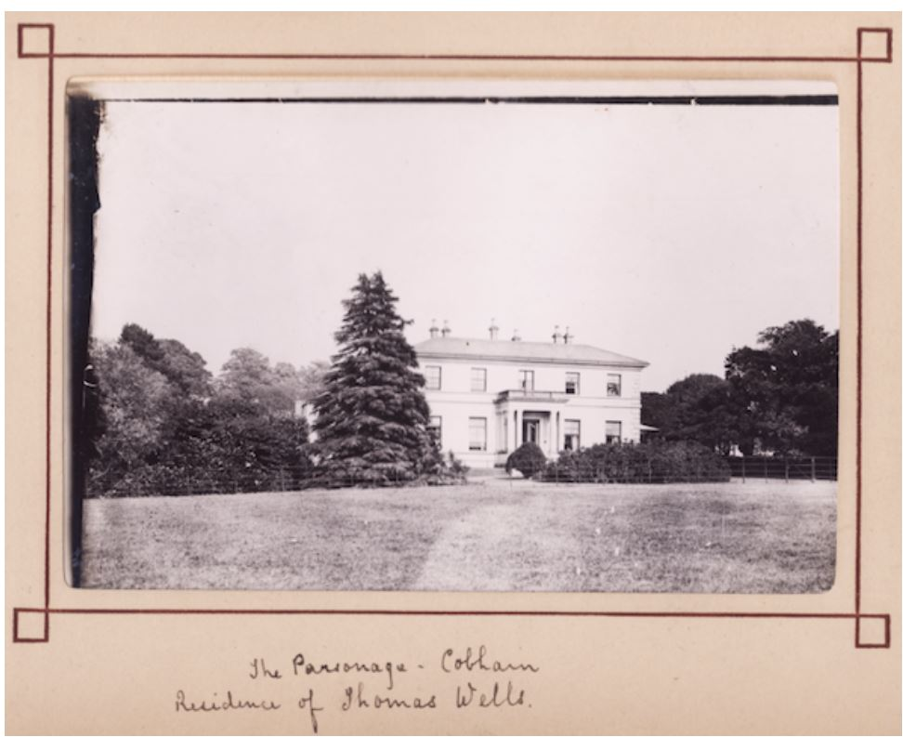
Visitors also learn that the sisters, none of whom married, lived for most of their lives in a house known as The Parsonage but, sadly, they will not be able to find this house as it was demolished in the 1950s, after the death of Emma Jane. The only hint as to where it stood is a sign with the words “The Old Parsonage”.

An idea of the fine house that once stood on the spot can be gained from the above photograph, taken some time in the 1880s, when it was the home of Thomas Wells (1796-1888), a wealthy farmer and the great-uncle of the sisters.
It turns out that the property was originally purchased by Thomas’s great-great-grandfather – and my 6xgreat-grandfather - William Pemble (1658-1727), a woollen draper from Shoreditch, back in 1701. I say ‘property’ because the house bought by William could not have been the one in the photograph. As pointed out by Angela Cook, who works for the organisation “Save Our Parsonages”, the house is clearly of a later date, being Georgian or Regency in style and thus built between 1780 and 1820. It is therefore either a new house built on the site of the old one or, as Angela says, more likely an aggrandisement of the existing house.
Whatever size of house William the woollen draper bought, it passed from him to his son and namesake Rev. William Pemble (1694-1729), who was vicar of Cobham but also of Gillingham. Rev. William appears to have lived in Gillingham and to have put the Parsonage in the care of his brother-in-law Michael Comport. Unfortunately, he died only a couple of years after his father and the Parsonage passed to his younger brother, Thomas Pemble (1699-1759). There is a gap in my knowledge of the house here: either Thomas’s widow Susanna née Osborne Hall lived there until her death in 1771 or it continued in the care of the Comport family. Whichever was the case, the next owner and occupier was the son of Thomas and Susanna, yet another William.
It was during the ownership of this, the third, William Pemble (1741-1823) that the house we see in the photograph was built. From an inventory of his estate, published after his death, we know that the house had 6/7 bedrooms, 3 reception rooms a kitchen, dairy, store, laundry and wash house. By his time it had clearly become a farm as the inventory includes ploughs, farm horses, barns, a granary and numerous farm implements.
William and his wife Rachel née Maplesden had no children and the Parsonage passed to his nephew, Thomas Wells (1757-1837), son of his sister Mary. The next owners were Thomas’s two sons: first his elder son with the nice composite name of William Pemble Wells (1788-1850) and, on this son’s death, his younger son and namesake, the Thomas Wells (1796-1888) of the photograph. Thomas’s wife, Elizabeth née Colyer, died only 12 years after they were married and the childless Thomas went on living in the big 7-bedroom house in the company of a housekeeper, a cook and a groom for another 30 years.
From censuses we learn that the Parsonage was now known as Parsonage Farm, and as such, it passed to Thomas’s nephew, Thomas Stevens (1813-1893), son of his sister Catherine. It was still a large farm in the time of Thomas Stevens and his wife Frances née Pye but, with his death, its days were numbered. Although Emma Jane, Thomas’s third daughter, lived on there until she died in 1953, she had no heirs and the large house suffered the fate that awaited so many grand old buildings. According to the Cobham Conservation Area Statement, published in 1999, all that then remained of the Parsonage was the “much restored coach-house, now a house, and a fine brick wall at the back of the site”.
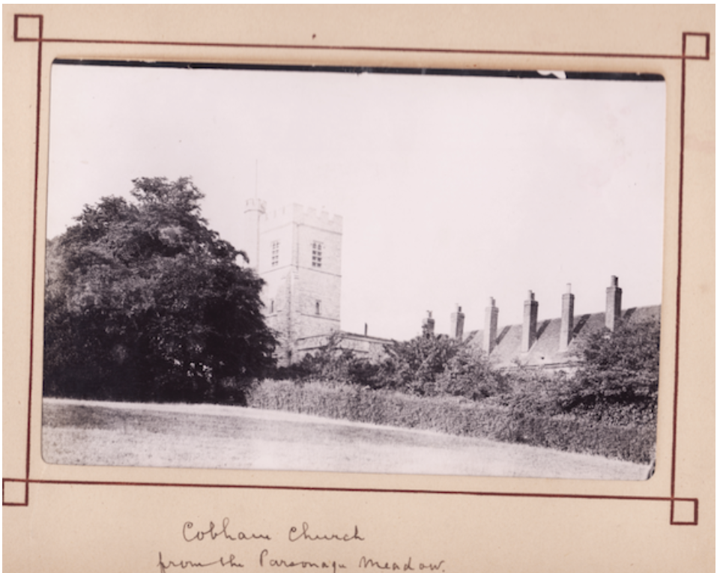
The view above of St Mary Magdalene, taken from near the Parsonage, may not have changed that much over the years. The most striking difference is probably the number of chimneys. The College complex originally consisted of 21 small almshouses round a quadrangle, each one with its own chimney. After an inspection in 1980, the almshouses were closed as they no longer met modern standards. The whole complex was upgraded into 12 self-contained flats heated by a central boiler, so only one chimney was needed. For aesthetic reasons, a number of new chimneys were built, but they are purely cosmetic.
The following map, taken from the Cobham Conservation Area Statement, shows the location of the Parsonage in 1895, not long after the photographs were taken when it would have been the home of the Stevens sisters.

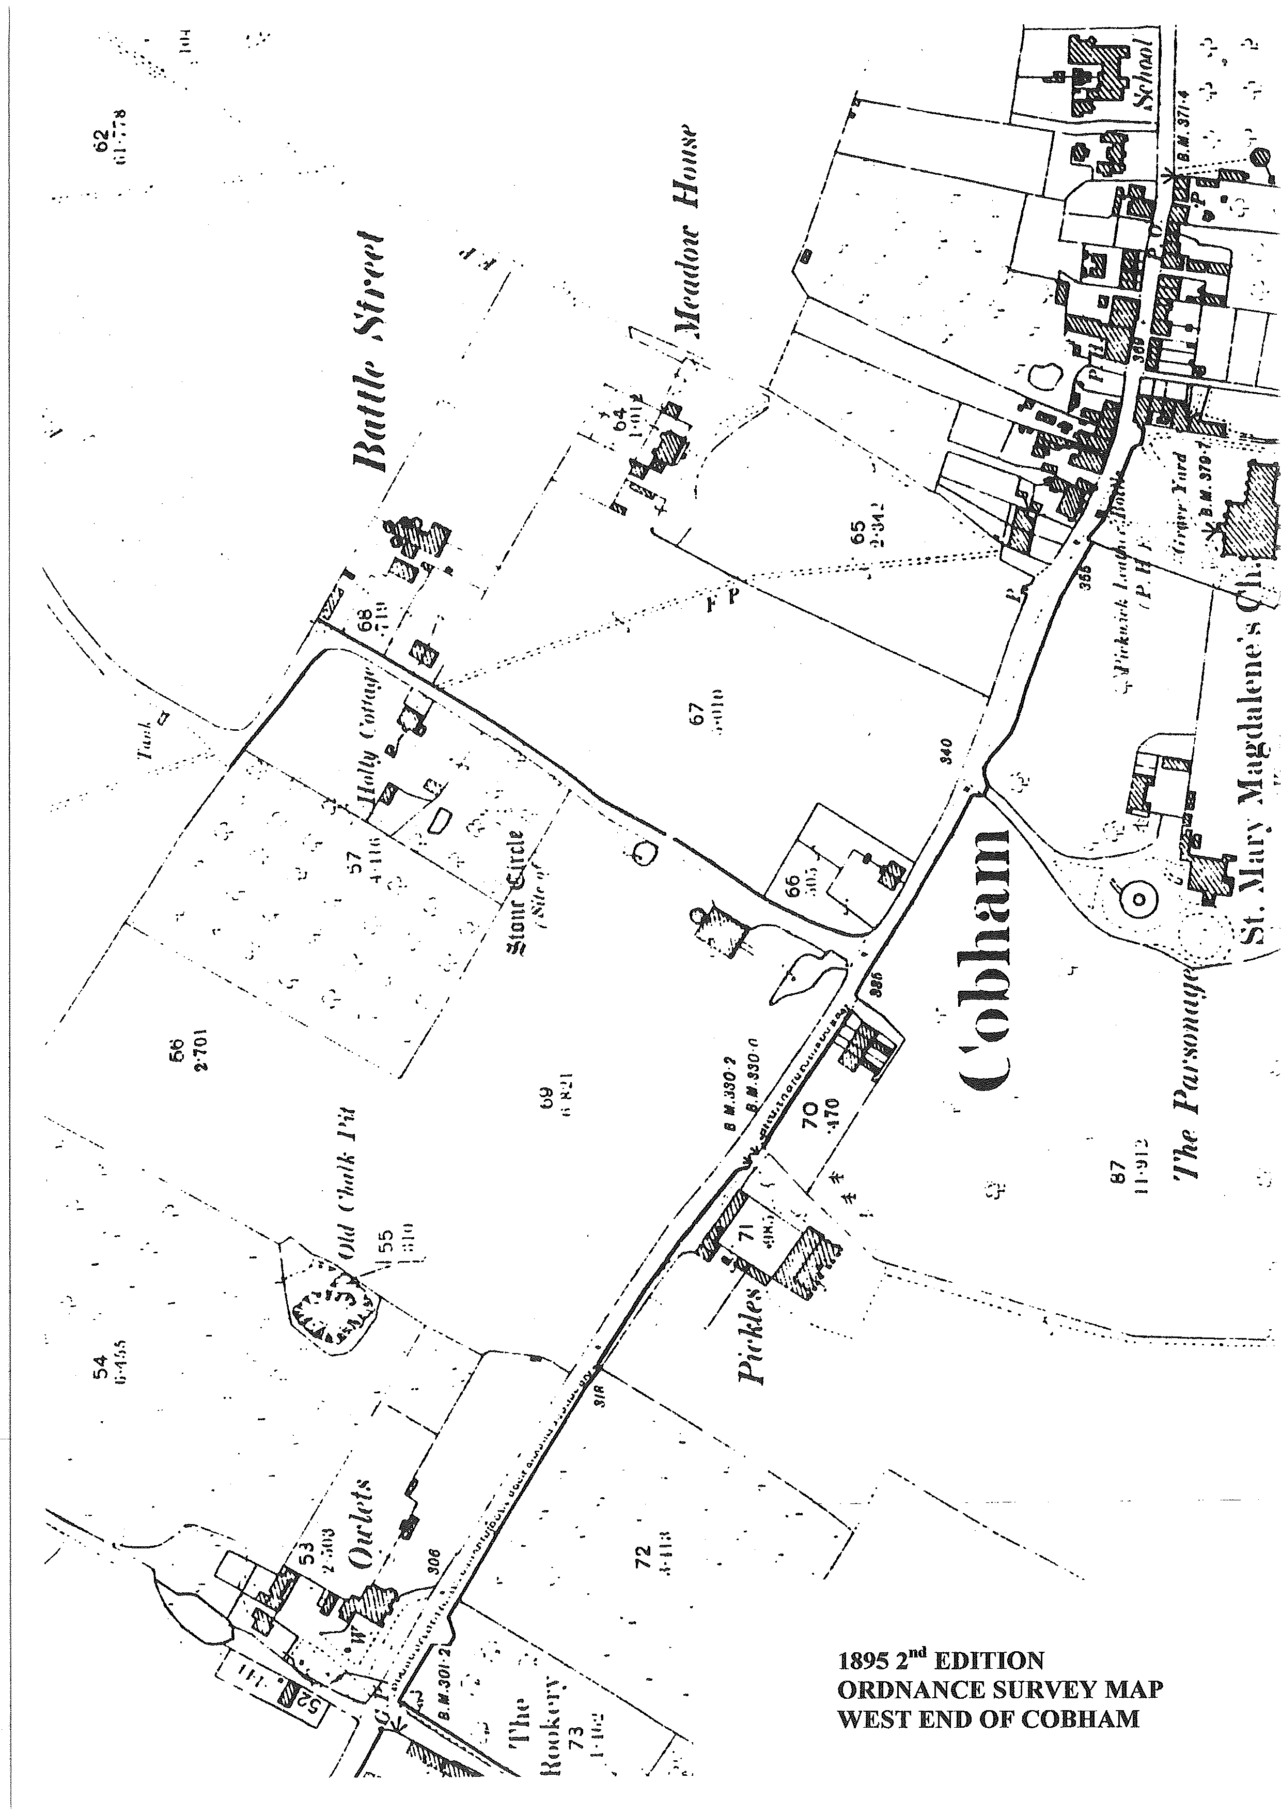

The Parsonage farm that we know today would seem to be located roughly on the site of the farm designated Pickles on the map.

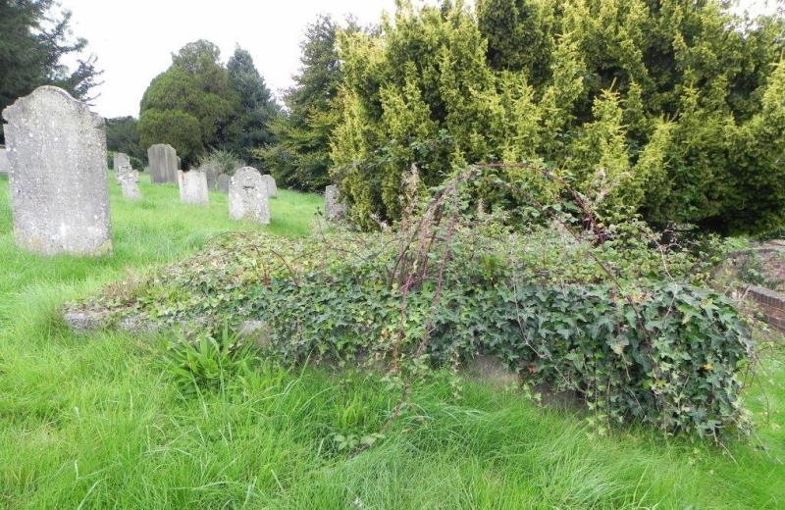
Memory of the Stevens sisters is kept alive by the Meadow Room. However, any memory there might be of their great-grandfather, Thomas Wells, has been erased. Or so I thought until Angela Cook, who had already enlightened me about the date of the Parsonage, acquired a record of the graves in Cobham churchyard from the vicar of St Mary Magdalene, Rev. Angela Walker (for which, many thanks). And there, among the graves listed, is the “Parsonage Vault”. The tireless Angela Cook located this vault, concealed though it is nowadays beneath a thick cover of ivy.
Photo: © Angela Cook
Inscribed on memorials (now covered) on top of the vault are the names of the people buried there. These include the four Stevens sisters, their parents Thomas and Frances (née Pye) Stevens, their grandparents Edmund and Catherine (née Wells) Stevens, several granduncles and grandaunts, and finally their great-grandfather Thomas Wells “whose earthly tabernacle was dissolved the 28th of December 1836 in his 81st year” and great-grandmother Susanna née Tiesdell (my 3xgreat grandparents).

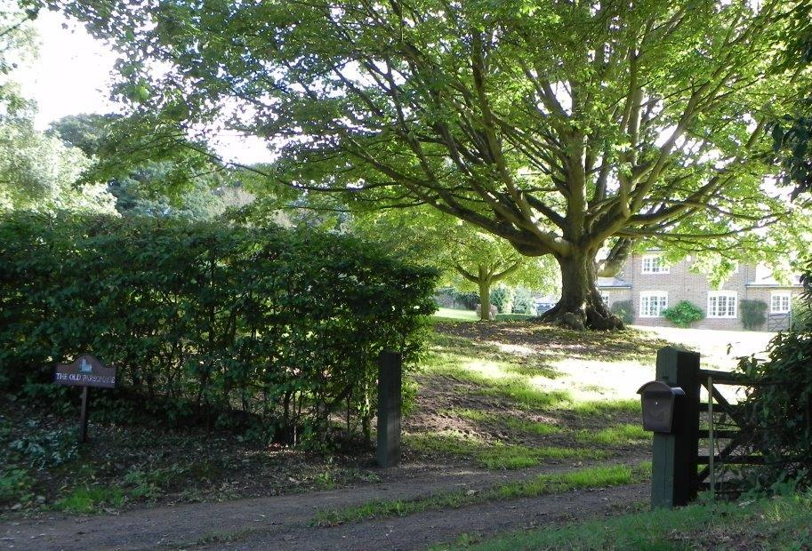Photo: © Angela Cook

However, the only memorial to the actual Parsonage is a sign (bottom left) near the Coach House that says The Old Parsonage. As Angela Cook pointed out, few people nowadays realise that a Georgian house, the home of many generations of my ancestors, once stood on this spot. It is some consolation that at least the Stevens sisters have a very visible memorial in the form of the Meadow Room.

